Session 2
Task 1: Identify Features and Label in Spotify Dataset
Objective: Load the Spotify Top 50 Songs dataset and determine which columns are features (independent variables) and which is the label (dependent variable) for predicting a song's popularity score.

Code
import pandas as pd

# Load dataset (downloaded from Kaggle as 'spotify_top50.csv')
df = pd.read_csv('spotify_top50.csv')

# Preview the dataset
print(df.head())
print(df.columns.tolist())

# Define features and label
label = 'popularity'

features = [
'danceability', 'energy', 'key', 'loudness', 'mode',
'speechiness', 'acousticness', 'instrumentalness',
'liveness', 'valence', 'tempo', 'duration_ms'
]

X = df[features] # Feature matrix
y = df[label] # Target / Label

print(f'Features shape: {X.shape}')
print(f'Label shape: {y.shape}')

Explanation
In supervised machine learning, we distinguish two types of variables:

Features (Independent Variables / X):
These are the input columns used to make predictions. They are called 'independent' because they are not influenced by other columns in the model. In this Spotify dataset, columns like danceability, energy, loudness, tempo, valence, etc. are features — they describe properties of a song.

Label (Dependent Variable / y):
This is the output column we want to predict. It is 'dependent' because its value depends on the features. Here, the popularity column (a score from 0–100 on Spotify) is our label.

Column | Type | Description
danceability | Feature (X) | How suitable a track is for dancing (0.0–1.0)
energy | Feature (X) | Intensity and activity level of the track
loudness | Feature (X) | Overall loudness in decibels (dB)
tempo | Feature (X) | Estimated tempo in beats per minute
valence | Feature (X) | Musical positiveness conveyed by track
acousticness | Feature (X) | Confidence the track is acoustic
speechiness | Feature (X) | Presence of spoken words in track
popularity | Label (y) | Popularity score 0–100 — what we PREDICT

Task 2: Train-Test Split Using sklearn
Objective: Split the dataset into 80% training and 20% testing sets using sklearn's train_test_split and print the row counts.

Code
import pandas as pd
from sklearn.model_selection import train_test_split

df = pd.read_csv('spotify_top50.csv')

features = ['danceability','energy','loudness','tempo',
'valence','acousticness','speechiness','liveness']
label = 'popularity'

X = df[features]
y = df[label]

# Split: 80% train, 20% test, random_state for reproducibility
X_train, X_test, y_train, y_test = train_test_split(
X, y, test_size=0.2, random_state=42
)

print(f'Total rows : {len(df)}')
print(f'Training rows : {len(X_train)} ({len(X_train)/len(df)*100:.0f}%)')
print(f'Test rows : {len(X_test)} ({len(X_test)/len(df)*100:.0f}%)')

Expected Output
Total rows : 50
Training rows : 40 (80%)
Test rows : 10 (20%)

Why We Split Data
- Training Set (80%): The model learns patterns from this portion.
- Test Set (20%): Used only after training to evaluate how well the model generalises to unseen data.
- random_state=42 ensures the split is reproducible — same split every time the code runs.
- Never train and evaluate on the same data — it gives an unrealistically optimistic accuracy (data leakage).

Task 3: 5% Training Split — Underfitting or Overfitting?
Objective: Train a linear regression model on only 5% of the data, evaluate on train and test sets, and determine if this causes underfitting or overfitting.

Code
import pandas as pd
import numpy as np
from sklearn.model_selection import train_test_split
from sklearn.linear_model import LinearRegression
from sklearn.metrics import mean_squared_error, r2_score

df = pd.read_csv('spotify_top50.csv')
X = df[['danceability']]
y = df['popularity']

# Intentionally use only 5% for training
X_train, X_test, y_train, y_test = train_test_split(
X, y, test_size=0.95, random_state=42
)

model = LinearRegression()
model.fit(X_train, y_train)

# Predictions
y_pred_train = model.predict(X_train)
y_pred_test = model.predict(X_test)

# Metrics
print('=== Train Set ==='
print(f' R² Score : {r2_score(y_train, y_pred_train):.4f}')
print(f' RMSE : {np.sqrt(mean_squared_error(y_train, y_pred_train)):.4f}')

print('=== Test Set ==='
print(f' R² Score : {r2_score(y_test, y_pred_test):.4f}')
print(f' RMSE : {np.sqrt(mean_squared_error(y_test, y_pred_test)):.4f}')

Expected Output (approximate)
=== Train Set ===
R² Score : 0.31 (low — model fits even its own training data poorly)
RMSE : 14.20

=== Test Set ===
R² Score : 0.08 (very low — barely explains variance)
RMSE : 17.40

Observation & Explanation
Verdict: This scenario causes UNDERFITTING.

Here is why:
- With only 5% of data (about 2–3 rows for a 50-row dataset), the model has almost no information to learn from.
- The model cannot learn the true relationship between danceability and popularity — it draws a nearly meaningless regression line.
- Both train and test R² scores are very low. In overfitting, train R² would be high while test R² is low. Here, both are poor — a hallmark of underfitting.
- Using a single feature (danceability) with very little training data = a simplistic model that fails to capture even basic patterns.

Key Rule:
Overfitting = high train accuracy, low test accuracy. Underfitting = low accuracy on BOTH sets.

Task 4: Bias–Variance Tradeoff Graph & Zomato Example

The Graph
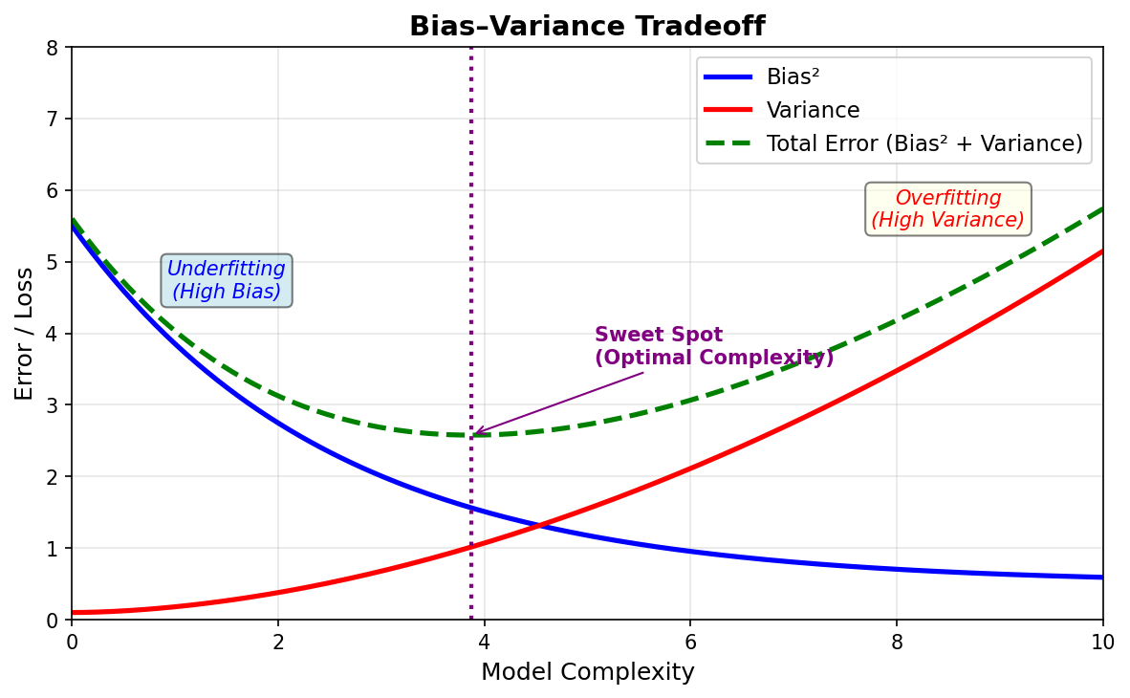
Figure 1 — Bias–Variance Tradeoff: As model complexity increases, bias falls but variance rises. The optimal model sits at the minimum of Total Error.

Reading the Graph
- Bias² (blue line): Error from wrong assumptions in the model. A simple model has HIGH bias — it misses important patterns (underfitting).
- Variance (red line): Error from sensitivity to small fluctuations in training data. A complex model has HIGH variance — it memorises noise (overfitting).
- Total Error (green dashed): Sum of bias² + variance + irreducible error. This curve has a minimum — the sweet spot.
- Sweet Spot (purple dotted line): The optimal model complexity that balances bias and variance, giving the lowest total generalisation error.

Application to Zomato Restaurant Rating Predictor
Suppose Zomato builds a model to predict a restaurant's rating (1–5 stars) based on inputs like cuisine type, location, average cost, number of reviews, and delivery time.

High Bias (Underfitting) Scenario:
If Zomato uses only average cost to predict rating (too simple), the model would predict similar ratings for all restaurants and fail to capture that a cheap street-food stall near a college might be rated higher than an expensive restaurant in a bad location. Both training and validation errors would be high.

High Variance (Overfitting) Scenario:
If Zomato uses an extremely deep decision tree with 50+ features (too complex), the model might perfectly predict ratings for training restaurants but fail on new ones — for example, memorising that 'Café XYZ in Koregaon Park has 4.3 stars' instead of learning generalised patterns.

Balanced Model (Sweet Spot):
A well-tuned Random Forest or Ridge Regression on ~8–10 meaningful features (cuisine, location tier, avg cost, review count, delivery speed) would sit at the sweet spot — generalising well to newly opened restaurants that were never in the training data.

Task 5: Real-World Overfitting Example — Swiggy

App: Swiggy (Food Delivery)
Scenario: Swiggy's personalised recommendation algorithm

The Overfitting Situation
Suppose Swiggy trains its recommendation model heavily on your past 3 weeks of orders — a period when you were sick and ordered only khichdi, soup, and dal from a single restaurant. The model over-learns this narrow pattern.

Now, even after you recover, Swiggy keeps recommending the same light, bland food and that one restaurant at the top — even when you search for pizza or biryani. When your flatmate logs in from your device, they also get these irrelevant recommendations.

Why This is Overfitting
- The model fit too tightly to a short, unrepresentative window of training data (3 weeks of illness-driven orders).
- It memorised specific noise (temporary behaviour) rather than learning the general pattern (your actual food preferences).
- It performs well on that specific training period but generalises poorly to new, normal ordering behaviour — exactly the definition of overfitting.

How to Fix It
- Use a longer and more diverse training window (e.g., 6+ months of order history).
- Apply regularisation to prevent the model from over-weighting recent or extreme behaviour.
- Include collaborative filtering — learn from users with similar overall taste profiles, not just your own narrow history.

Quick Reference Summary

Concept | Definition | Real-World Sign
Feature (X) | Independent input variables used to train model | danceability, tempo, energy in Spotify
Label (y) | Dependent output variable we want to predict | popularity score in Spotify
Train Set | 80% of data; model learns from this | 40 songs out of 50 in Spotify dataset
Test Set | 20% of data; evaluates generalisation | 10 songs never seen during training
Overfitting | Model memorises training data, fails on new data | Swiggy recommends only illness-period food forever
Underfitting | Model too simple; poor on train AND test data | 5% training — low R² on both sets
High Bias | Model makes strong wrong assumptions | Predicting Zomato ratings using only price
High Variance | Model is over-sensitive to training data | Deep decision tree memorising each restaurant

— End of Assignment: Session 2 — Core ML Concepts —

